Computer Language Coding Concepts

Class Assignment in a Diagram
The principle of class assignment is explained in the article Class Assignment. This article demonstrates the expression of it in a diagram.

This article will not cover the notation of assignment in general. For the notation of assignment in general, see the article Assignment in a Diagram.

An assignment is a call to an assignment command, but the expression of an assignment call is given a more basic notation, than a normal command call, like this:

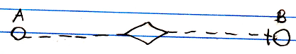

The fact, that the lines are dashed, expresses, that it is a class assignment. The access mark indicates the direction. The target class of symbol A is assigned to symbol B.

Command definition assignment is also a class assignment. A command definition assignment can look like this:

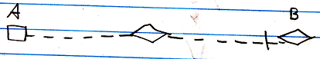

In the example above, symbol A is a non-executing (square) command symbol, and symbol B is a diamond, which stands for a call, but both symbol A and B cold have been either squares or diamonds.

See also: Assignment in a Diagram, Class Assignment

Author & Copyright: Jan-Joost van Zon Date: July 13, 2008 – July 24, 2008 Location: Oosterhout, The Netherlands Status: Finished

